PIKE COUNTY SCHOOLS
EMPLOYEE SELF SERVE (ESS) INSTRUCTIONS

MUNIS Employee Self Serve (ESS) is utilized by Pike County Schools for electronic delivery of pay notifications, W2 information, job opportunities and other employee information. A link to the site is provide on the Pike County Schools website under Quick Links/Staff Links. The direct URL is https://pikeky.munisselfservice.com/ .

Login Instructions: Your user name is your Employee ID number located on your ID badge. It is a four or five digit number. The first time you log in your password will be the last four digits of your social security number. As soon as you log in, you will be asked to create a new unique password. Criteria for the password is on the “create password” page. After you create your new password, you will use that password to login the next time you access ESS. After logging in you will get this screen the first time:

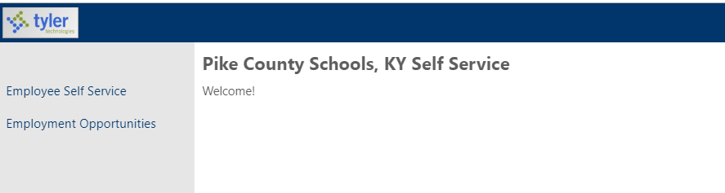

After the first time, the “Log In” button is in the upper right corner of the site and it will log in to the Employee Self Service Screen with your personal information.

EMPLOYMENT OPPORTUNITIES – This is a link to the Personnel Department list of posted jobs in Pike County Schools. From there you can click on “apply” for any position you are interested in applying.

EMPLOYEE SELF SERVICE (ESS) – When you click on ESS, you get a screen that lists your Personal Information, which includes name, address, phone and email. You also get a snapshot of your “time off” for the current year and your available days. The types of days are highlighted in different colors. If you click the “show time off taken” button, the days taken will be highlighted on the bar chart. If you click on a specific block, the actual day/type time off taken will show on the right of your screen. NOTE: IN ORDER TO CLOSE THE FISCAL YEAR AND POST NEW VACATION/SICK/PERSONAL LEAVE DAYS, THE SYSTEM MUST CLOSEOUT OLD DAYS ON JUNE 30 AND REPOST THEM TO JULY 1; THEREFORE, ALL EMPLOYEES WILL HAVE JUNE USED DAYS IN ALL AREAS. THIS DOES NOT AFFECT YOUR BALANCES.

NOTE: IF YOU HAVE MULTIPLE JOBS WITH TWO DIFFERENT EMPLOYEE NUMBERS, YOU CAN GO BETWEEN THE JOBS BY CLICKING YOUR USER NAME IN THE UPPER RIGHT OF THE SCREEN AND CHOOSING THE OTHER WORK LOCATION FROM THE DROP DOWN BOX. IF BOTH JOBS ARE AT THE SAME LOCATION, THEN JUST CHOOSE THE SECOND LISTING OF THE SAME LOCATION. EXAMPLE:

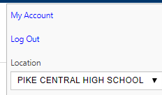
Also on that screen you will find a quick link to the last few checks with a detail button next to them for a quick view. Quick links to other areas will be explained later in this document. Images of checks are not presently available, but will be in a future upgrade. If you double click on the blurred image it will show the gross amount of last payroll check OR the year to date amounts.

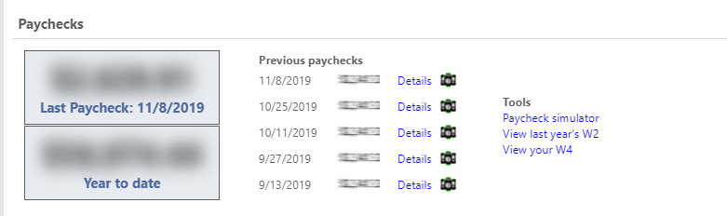

When you click on ESS you also get the following drop down options explained below:

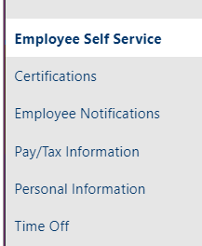

Certifications – This tab will list all certifications that are presently listed in MUNIS under your employee record. Certified staff will have several. Most classified will not have any.

Employee Notifications – This tab would be for any notifications sent out by the District through ESS. At present, we are in the process of developing this section.

Pay/Tax Information – This tab shows each check (newest first) for the current year. For detail you can just click on the detail button on the far right of each line item. NOTE: You can change the calendar year at the top to any year available on the dropdown. That is true for any screen that has the year drop down option. This tab also gives you the following drop down options:
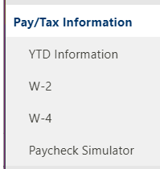
YTD Information – Gives you a snapshot of your calendar year to date totals.
W2 – Gives you a snapshot of your W2 for the year requested in drop down box.
W4 – Gives you a snapshot of your W4 (Federal Withholding) and K4 (Kentucky Withholding)
that YOU filed with Central Office. You cannot change these options without completing a new
W4 or K4 and submitting to the Payroll Office.
Paycheck Simulator – This allows you to change options on your deductions to see how it would
change your “net” take home pay. You can change your gross earnings, filing status on your W4
and K4, number of withholdings and deduction amounts. After making changes, hit calculate for
results. NOTE: This does not change your ACTUAL payroll information.

PERSONAL INFORMATION: This section gives you your personal information. There are four (4) tabs at the top. Each tab contains different information and some fields are available to edit. To edit hit the “edit” button on the screen you want to edit, make your change and click the save button.

Tab 1: General – You may edit only your “preferred name” on this screen.
Tab 2: Demographics – You may edit all the fields on this screen.
Tab 3: Contract – You may edit Emergency Contacts and Telephones on this screen.
Tab 4: Dependents – not used.

If you click “Job Information”, you will get the basic information on your position(s).

Time Off: This section gives you the specifics on your “leave days” such as vacation, sick, personal and days missed without pay. This is a one-screen “snapshot” of the status of your days. Click on each type of leave to see details.

LOGOUT: Click on your name in upper right corner of screen. Click on “logout”.

Frequently Asked Questions:

CHANGING PASSWORD

- I have logged in and I want to change my password to a different one:
  - Click on your user name in upper right hand corner and chose the “My Account” option in the dropdown box that appears. Click on the “Change Password” option on the screen that appears.
- I have forgotten my password and cannot login:
  - Click on the “login” option in the upper right hand corner and click on the “forgot my password” option. Follow instructions. Do not contact Finance/Technology because they are unable to change your password.

NOTE: PASSWORDS ARE UNIQUE TO EACH EMPLOYEE AND SHOULD BE KEPT PERSONAL.

